New Rittal CX console system
Flexibility with numerous options
Herborn, 2024-08-12
A clear overview and absolute dependability are essential wherever equipment and system operation must be monitored. Here, at the human/machine interface, it is also vital to possess flexible options for individual adaptation to any local circumstances. That is exactly what Rittal kept in mind when developing its new CX console system and CX one-piece console, both of which offer wide-ranging installation options using system accessories.
With the new console system, users can choose from numerous options and can thus configure their console. Whether they need just a pedestal or a two- or three-part assembly including desk unit and upper console section, full flexibility is guaranteed. Simple handling ensures smooth installation. The CX one-piece console, too, allows a multitude of individual configurations. After all, both the console system and the one-piece console are compatible with the Rittal AX/VX system platform for compact and large enclosures.
An extensive range of accessories provides multiple interior installation choices, including base/plinth and cable entry options. Furthermore, a console pedestal with cover plate expands the range of available widths compared to a standard AX enclosure to up to 1600 mm – an ideal solution for users who are dependent on the larger dimensions.
Further innovations compared to the predecessor series (TopConsole) include the straightened alignment of the rear surfaces. This means that both wall mounting and the integration of a fan-and-filter unit or thermoelectric cooler are now possible without ado. A generous installation space with a depth of 500 mm in the pedestal provides for even simpler handling. In combination with heavy-duty support rails, which are available as accessories, the console is ideally equipped for the incorporation of heavy components such as transformers. Rittal also offers the digital wiring plan pocket ePOCKET as a standard feature, allowing paperless distribution of the equipment and system documentation. In this way, all maintenance and service tasks are managed simply and reliably.

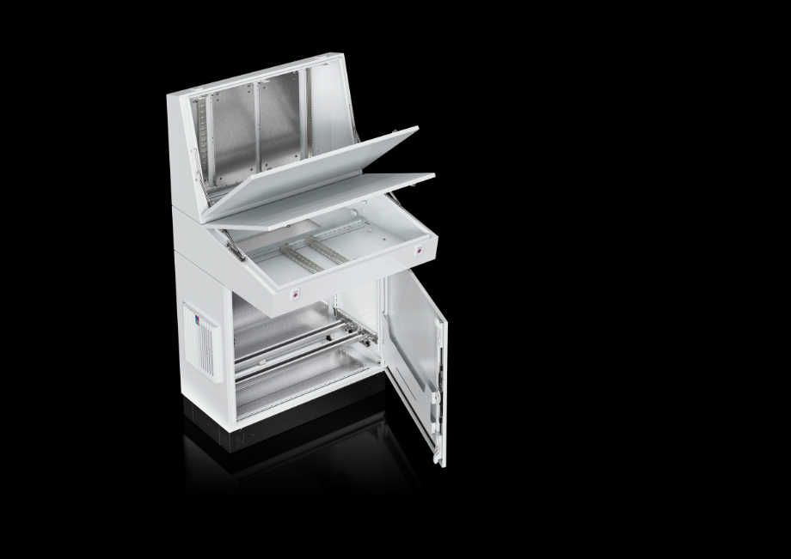 |  | 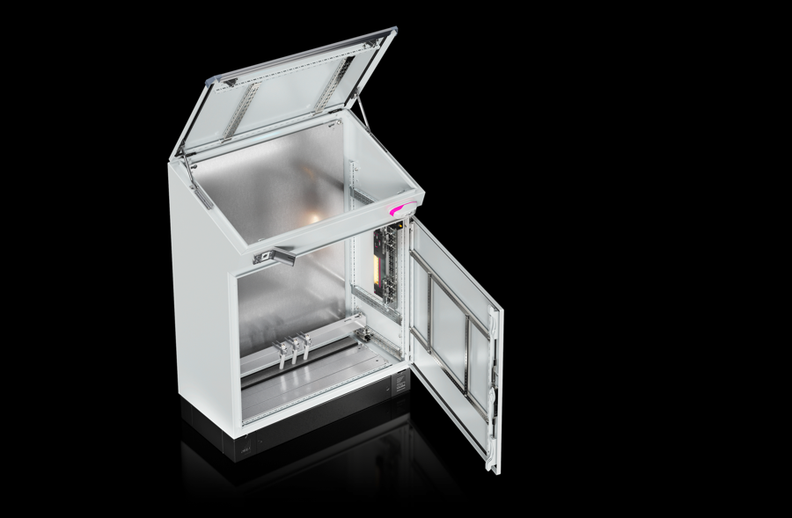
Image 1  With the new console system, users can choose from numerous options and can thus configure their console. Whether they need just a pedestal or a two- or three-part assembly including desk unit and upper console section, full flexibility is guaranteed. |  | Image 2  Both the console system and the one-piece console are compatible with the Rittal AX/VX system platform. A comprehensive range of accessories offers diverse possibilities for interior installation.

May be reproduced free of charge. Please name Rittal GmbH & Co. KG as source.

Rittal

Rittal is a leading global supplier of enclosure systems, automation and infrastructure with its industrial, IT, energy and power, cooling and service units. Rittal products and solutions are used in over 90% of global industries – standardised, customised, and always of the very best quality.
Our approach and methodology: Rittal, Rittal Software Systems (Eplan, Cideon and German Edge Cloud) and Rittal Automation Systems (RAS, Ehrt, Alfra) combine their hardware and software expertise to streamline, optimise and digitalise processes across the entire value chain for our customers including their IT infrastructure – from control and switchgear construction, machine building to factory operators or the energy sector.
Our delivery promise: Rittal standard products are delivered in Germany within 24 hours, and within 48 hours throughout Europe.
Customer focus
Improving efficiency and increasing productivity through automation and digitalisation is one of the biggest challenges for our customers. This requires in-depth knowledge and expertise, the combination of hardware and software, and cross-sector networking. We are convinced that creating and connecting data rooms is crucial to the success of industrial transformation. And that is exactly our speciality and field of competence.
Eplan and Rittal are driving the development of the digital automation twin, making data accessible and useable in operations as well. Cideon is improving data consistency in the digital product twin context with its CAD/CAM, PDM/PLM and product configuration expertise. German Edge Cloud’s ONCITE Digital Production System (DPS) makes production process data transparent, enabling it to be optimised – right through to energy management using digital production twins.
Sustainability
Environmental and climate protection, social commitment and ethical corporate management are a given for Rittal. We take our responsibility for a sustainable future seriously. Our approach to resource management and conservation involves continuous improvement of our own production processes and ensuring that our products have the lowest possible Product Carbon Footprint. Our solutions support our customers in achieving their own climate targets.
Family business and global player
Founded in 1961, Rittal is the largest company in the owner-operated Friedhelm Loh Group. The group operates worldwide, with more than 12 production sites and over 95 international subsidiaries. It has more than 12,100 employees and posted revenues of 3 billion euros in fiscal 2023. In 2023, the Friedhelm Loh Group was presented with the “Best Place to Learn” and “Employer of the Future” awards. In 2024, Rittal was awarded the Top 100 Seal as one of Germany’s most innovative medium-sized companies for the third time in a row.
For more information, visit www.rittal.com and www.friedhelm-loh-group.com.

Corporate Communications
Dr. Carola Hilbrand Rittal GmbH & Co. KG
Corporate & Brand Communications Auf dem Stützelberg
Tel.: 02772/505-2527 35745 Herborn
hilbrand.c@rittal.de www.rittal.com


Follow us:

